Remembering The Tent Complex Decade
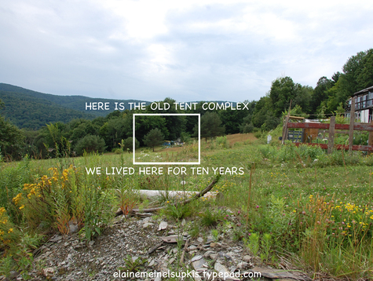
July 11, 2008
july 11, 2008
Elaine Meinel Supkis
Dear readers, I periodically mention living ten years in a tent complex my son and I built after my husband was injured at work and we were stuck in the court system, fighting to keep him alive. Those years were a true marathon effort to stay alive. We had less than $500 a month to live on and we kept on paying off our debts so we actually had less then $200 a month for everything. The ruins of the tent complex are still visible and I am dismantling it this summer so time to remember a difficult time that was also one of the most beautiful and amazing time for all of us, even my husband who suffered by far, the most.
CLICK HERE FOR CARLOS NAKAI MUSIC
If you stand in my driveway which is half a mile up a mountainside, you can see in the distance a varicolored ruin. This is the remains of what once was a huge, comfortable nest my son and I built during the years we had no money and little hope but lots of love to share. It is nearly flat now, crushed by 8 years of storms, snow, wind, trees falling on it and animals making new homes in it. It is, like any great castle, a ruin with its own special artistic elements. So today, I took one of the dogs over to photograph it.
Remember: we are in this terrible mess caused by too much money piled on houses which crushed them just as certainly as snow crushed this tent! Yet people don't know how little it takes to live and be happy in very strange places, very peculiar structures THAT COST NEARLY NOTHING. Yes, this tent complex, nearly all of it, we made from free materials my son and I collected passionately and persistently. Many good friends contributed to this by finding and bringing more and more things to add to this business of ours.
During the 1991-1993 recession we even had friends move into our tent complex with us! After all, it was about as cheap as housing gets. Not only that, we had running water when it rained, we melted snow on the stoves in the winter for water. We used an old stocktank which was put in our bedroom as bathing water. I put logs under it to heat it up. In summer, Mr. Toad lived in that cave under the tub. We even made a little door for him to go in and out of the tent!
In this tent complex was the ox stables, the horse stables, the sheep fold for 45 sheep, a duck house, and a chicken pen. And two dogs and 4 cats lived in the main tent rooms. We all lived literally under one roof. It was immense fun.
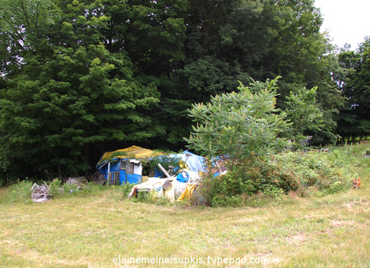
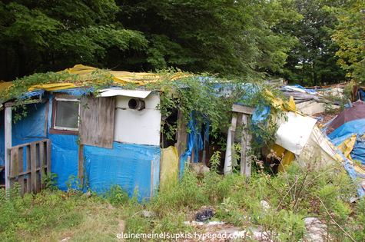
This was the front door. The first road up the mountain did a hairpin turn and came up to the edge of the deep, dark forest. There, under the eaves of the tall trees, was the tent complex. This door was built the second year in the tent. The first year, we had only one room, what became our bedroom. This door led to the kitchen and living room. In these rooms was a water storage tank that was 250 gallons, a water barrel above the sink that was 55 gallons, a Victorian wood stove for cooking, a big wood stove for heating in winter. Once, it went down to -40 degrees F in winter! Luckily, there was a blizzard so we had several feet of snow insulting the tent complex!
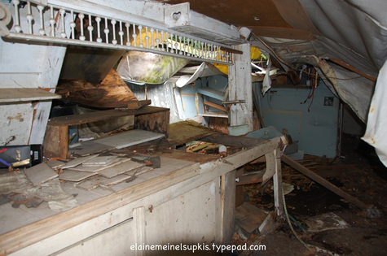
Around the centerposts, I built a table. In the cloth roof, I put in two skylights which we can see in the following pictures.
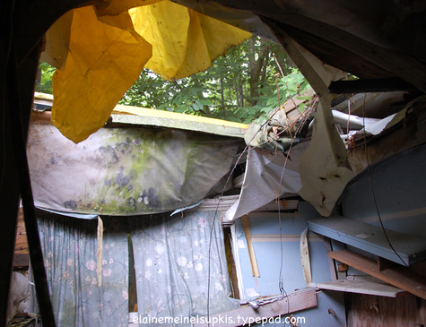
And here is where the Victorian stove was. Each stove had its own chimney that was build out of the sheets of steel used to cover the wood pallets that transported buckets of tar. The guys at Curtis Lumber collected these for me and I ended up with dozens of sheets of steel this way.
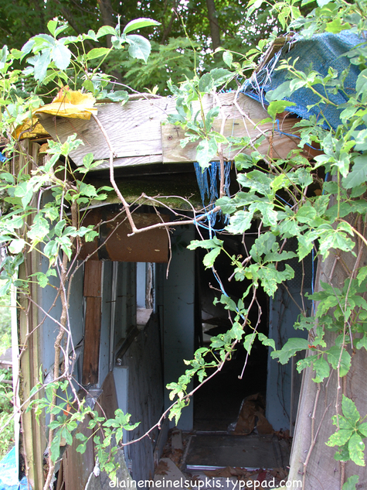
I look at all of this and am filled with great emotions of intense depth. Even today, I can remember how I felt the first day I set to work to clear the ground for the very first tent. We already had staked out the house. It was just a hollow next to the forest. I didn't want to be too hot. It turned out to be 'the Snow Hole' in winter. Long after snow melted elsewhere, it was dead winter at the tent! But in summer, it was cool and shady.
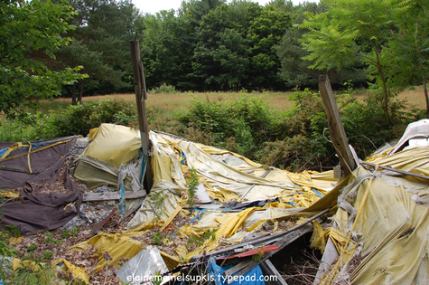
The oldest part of the tent has totally collapsed. It was not as solidly built as the later parts. This was because we thought we would be living in it for only a year, not a decade. We had this pit under the heavy feather bed in the middle of that room. When tornadoes or huge storms roared in, we hid there with the radio. Once, a tornado formed right over head and then roared down Rt. 22, it destroyed a garage and parts of several houses. My husband said, 'Look, Elaine! The rain is going straight up and it is getting dark!' I have been near tornadoes so I lunged for under the bed.
Another time, a deadly series of 25 tornadoes tore through the region, killing people. We hid under the bed all night that time. We were also hit by lightning in the tent. Then there was the blizzard that nearly blew us away. Out in the 80 mph winds we were, using logging chains tp throw over the roof and secure them to the base of various oak trees! Then there was Hurricane Hugo which roared in. We ran OUT of the tent complex but we couldn't get all the animals out in time. A tree fell right between the sheepfold and the hen house! Not one animal was hurt.
Seriously, I am actually happy to be in a strong house. Heh. Once, before a big storm, one of the cats was chasing a forest rat up the roof of the tent when both of them fell through. I had to rush to a hardware store for a tarp! But the wind was howling. I couldn't hold it down. It billowed like the sail on a ship. So I hitched Chip and Dale, the oxen, to the ropes on one side and had them walk forwards while I used logging chains to anchor the other side. This way, we slid the new tarp which was 150 feet by 50 feet, over the whole complex. Just in the nick of time.
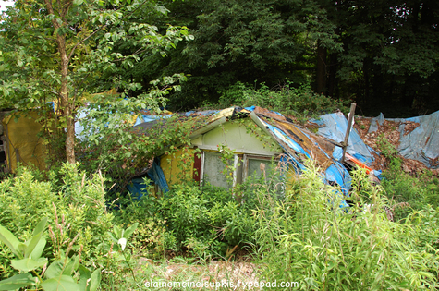+
The tent complex had three bedrooms because so many people came to live or visit with us. These were almost house-like because people wanting to stay with us would help us haul in more construction materials we collected from town dumps and construction left-overs given to me by guys who knew I was in difficulties. The picture above was my son's bedroom. The turkeys used to go to his bedroom window to eat insects. They would make happy turkey 'Blurp! Blurp!' noises while tap-tap-tapping. One turkey hen adopted a baby duckling. She happily herded it around and when she sat down, the duckie would sit on her back. One day, she stepped on it. This broke her heart. She trailed after me, wailing, 'Glurp! Glurp!'
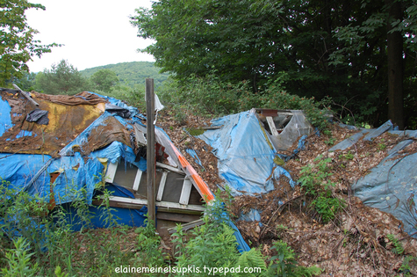
This was the guest room. I don't think anyone would want to stay there today. Still, the triple window is still there. Amazing.
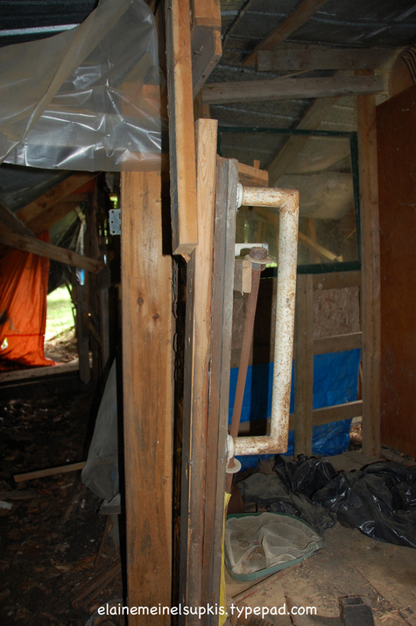
And this is the part where the oxen and horses lived. Sparky's stall was next to Chip's stall. Chip and Dale had these lovely golden balls on the tips of their horns. Sparky loved those balls. He would tease Chips until the ox would stick his horns into Sparky's stall to intimidate him. Sparky would then grab the ball with his teeth and pull. Eventually, he pulled them off! To the happiness of the oxen who could then use their sharp horns to rearrange the tent's interior. Rip! Tear! I would scold them. 'Bad boys! You do that, I won't give you any sweet mix!' Then they would moo at me and Sparky would chuckle. But when Sparky was bad, the sheep got HIS sweet mix! They would watch him with their beady little dark eyes hoping he would foul up and they get the splendid treats.
The chickens ended up living in the sheepfold. This is because of the very, very cold winter of 1994. They ended up sleeping on the sheep! Then, they discovered they could ride the sheep. It was hilarious to see the sheep run out into the pasture with chickens on their backs. That cold winter, a very tiny lambie was born during a violent blizzard in spring. I named her 'Itty Bitty'. I kept her alive for only one day. She had such an intense desire to live! But she was too small. Barely bigger than my hand. A baby lambie is the size of a human baby. The last thing she did was try to climb up to me, crying for her life. As I held her in my hands, she died. We cried a lot for her.
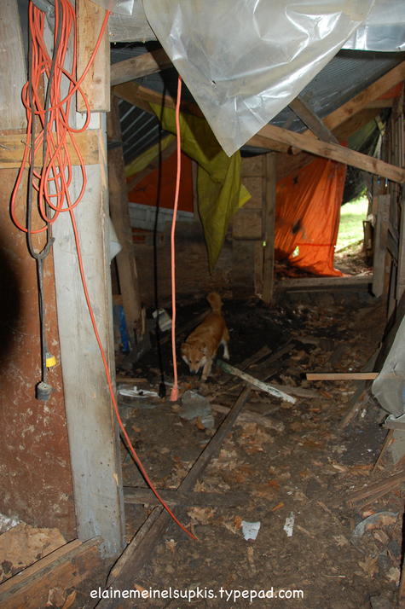
I even has this workshop where I built things for the house and did all the tool stuff for the house. This was an important room. A lot of the things in here were given to us as gifts by people who weren't using these tools anymore. It made the house possible. The point is, we can do so much if we want to do it. Nothing can stop us even if we are itty bitty and can't stay on this earth for very long, even so, the memories live on and now are across the planet.
For that is all there is: to remember, to recall, to love and to hold dear to the heart. One by one, our many animals died of old age, too. Their time here was set by Mother Nature and we have to endure our losses and count our blessings every day.
People ask me, 'What can we do today to save ourselves?' And are dissatisfied when I say, 'Love your family, care for your children, live life with wonder, care and know that everything is, in the end, an adventure. For good or ill, it still is an experience. And no one can put a price on this nor take it away. We can only lose it through dissatisfaction, distraction or anger. At every burial of a loved friend who shared this decade in a tent with us, most of them living while we all moved into the big house, every one of them, we shed tears and then laughed about all the many stories they gave us.
Aside from the obvious love of all these dogs, the horse, the oxen, the sheep, the ducks, everyone, the toad, even. They all gave us a great gift, one that didn't cost a penny. A gift of understanding what Life really means and how we can live in grace and joy, even when in sorrows. When Chris was at his sickest, I trained all the dogs and even the oxen to go searching for him by saying, 'Find Chris!' and off they would go, searching high and low. Even the sheep knew this after a while! Stella, the eldest, was best at finding Chris when he went out in despair to kill himself.
She is no longer with us but Chris is. And this was thanks to the animals and their obvious devotion to us. For animals can be devoted! They have hearts and they don't care for the things we treasure, they want to have a place at the hearth or a stall or a house of their own and to know we protected them. When the bears came to bother them, they knew we would chase it away. When the coyotes hunted the lambs, they knew they could run into the tent complex and be safe. When lightning lit up the sky, Sparky would neigh, toss his mane and charge to the tent for shelter! All the animals paid a lot of attention to us.
When my son grew up and left home, every time any of the animals spotted his school bus, they would get all excited and come running down to the bus stop only to see no one come up the mountain. Sad, they would hang their heads and come home to me and complain. To this day, when we say, 'Danny is coming!' They dance with undisguised joy! They know who he is and what this means! Utter bliss. They get the thing more valuable than money: attention and love! And they all love to be loved.
And I am certain, this is what we all want, too. Peace and love to everyone. Please take care and be optimistic no matter what.
July 11, 2008 | Permalink

TrackBack
TrackBack URL for this entry:
http://www.typepad.com/t/trackback/763647/31132656
Listed below are links to weblogs that reference Remembering The Tent Complex Decade:

Comments
Hello Elaine - you are wonderfully gifted.
Posted by: docrufus | July 11, 2008 at 10:17 PM
This is an even more incredible story and brought a tear to my eyes.
Determination to survive and love, rather than seeking comfort and material possessions, will be very valuable in the near future.
I am fascinated by the tents you built as well as their very powerful place in the human imagination throughout history as they were the only means of survival for many generations of people, no?
I was reading the Mormon Church Handbook of Instructions (1999) that was leaked via Wikileaks.
http://file.sunshinepress.org:54445/mormon-handbook-of-instructions-1999.pdf
"Most geographic areas of the Church are divided into stakes. A stake normally is composed of five to twelve wards and branches. The term stake comes from the prophecies of Isaiah, who described latter-day Zion as a tent or tabernacle that would be held secure by stakes (see Isaiah 33:20; 54:2). The stakes of Zion are like the stakes of a large tent that hold it secure so it protects all who enter."
====
This brings us to the Denver International Airport (DIA) that is built like a tent, perhaps a new age Masonic NWO cathedral.
Coincidentally right in the middle of NORAD and the several military bases, right in the middle of the country, with a mile of bedrock above sea level for digging survival tunnels that people who crave power so love.
http://www.geocities.com/Baja/5692/
"Numberous murals - (I have pictures of all) - promote paganism,indigenous people power and World Order. Much of the Indian spirituality has Aztec/Mayan overtones. Nature worship is a primary theme. One casket has a Christian child lying in it. Webb met with chiefs and witchdoctors of various Indian tribes, before the construction of the airport, because they were concerned it was being built over Indian burial and warring grounds, and that the spirits of the dead were angry. Thus, rituals were performed by their shaman and the "tent-like" terminal structure."

Posted by: GK | July 11, 2008 at 10:46 PM
You can’t take it when you go
that’s something that you oughta know
Love isn’t counted in gold
only in heart and soul
Dave Mason.....
Posted by: Gary | July 12, 2008 at 12:06 AM
How far upstate does one need to go to be able to build and live in a tent like this, without hassle from the town?
Posted by: Doug | July 12, 2008 at 12:09 AM
We chose to live in Berlin because it is a truly 'Wild West' town of the old sort. The people here don't hassle each other over stupid things. I have lived in places where you can't blink without being sued or harassed.
When the school first learned my son was living with no electricity or running water, they were worried and came to visit. Soon, they were charmed by all this.
Seeing my son's grades go up and his work get better and better because we read lots of books and played board games, etc rather than have electronic entertainment, the principal and staff decided he had a SUPERIOR lifestyle! 'Maybe all the students should live in tents,' said Mr. Stead to me one day.
His fellow students changed from mocking him at first to being rather envious of his interesting lifestyle. Also, when we had no money, the school helped out as much as possible.
It really was a nice situation.
Posted by: Elaine Meinel Supkis | July 12, 2008 at 08:13 AM

